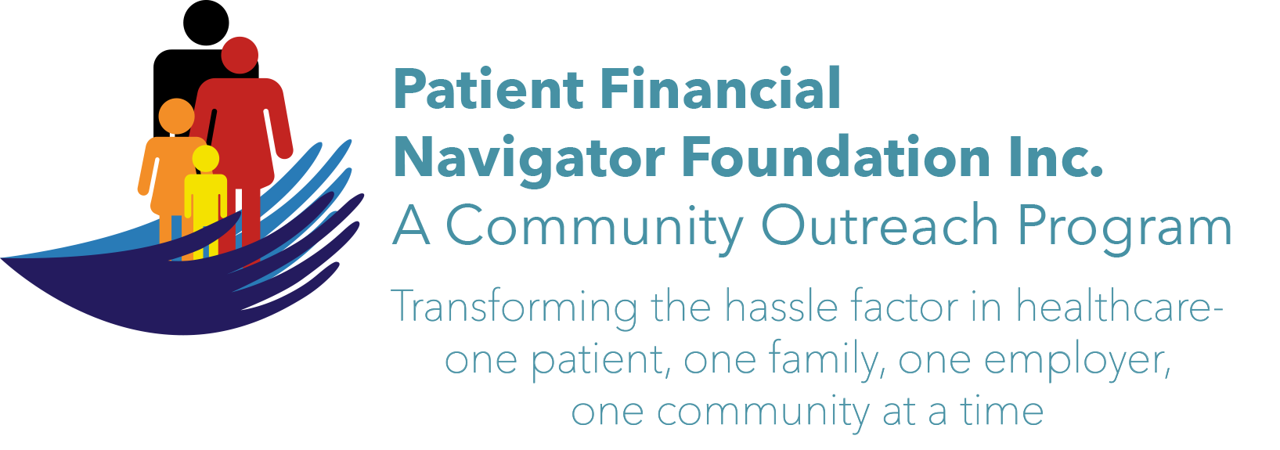 Article for HealthCare Buzz
Times News. Feb 2018
Article – 11
Turning 65: SCAMS – Part 1
Taenia Hudson, Senior Specialist/Insurance Coordinator at the Office on Aging/CSI is dismayed as she learns of the many scams being directed at senior citizens. Ms Hudson has participated in multiple PFNF-sponsored Boot Camps along with ongoing Office on Aging outreach. Below are five top scams along with the most common approaches being used. Beware!
- Healthcare scam.. “ I’m calling to let you know that we have a one-time offer that could save you money on your prescription drug costs. If you can provide me with your Medicare number and your checking account number, you could start saving money today!” Key alerts – 1x offer, today only – and never give anyone your Medicare number. Call 1-800-Medicare to report.
- Lottery scam. “Is this James Cohen? Mr. Cohen, I have great news…you’ve just won the Jamaican lottery! It’s worth $100,000,000 and to claim this prize, all you have to do is pay international taxes. If you can just provide your bank account information, we’ll deposit your winnings in your account today.” Or Thru an email alert of winnings. It is illegal to participate in lotteries outside the US. Jamaican or Nigerian ‘winnings’ are all fraud.
- IRS scam. “Mrs. Jones, this is Special Agent Trustworthy from the Internal Revenue Service. Our records indicate that you currently owe $23,295 in back taxes and I have a warrant for your arrest. I’m calling today to inform you that unless you pay these taxes immediately, the police will be arresting you.” Hang up! The IRS will always reach out by mail first. They will never ask for money over the phone.
- Romance scam. “Hello, Henry – this is Rose. I saw your profile on the Date-a-Con-Artist website and you sound like the kind of man I’ve been looking for. I understand you’re widowed – me too. I’m so lonely, I can’t believe I found someone like you so quickly! I’d love to meet you in person, but since I live on a fixed income, I can’t afford to travel out-of- state.” In 2015 the FBI documented 12,509 complaints, with $203,390,531 being lost. Nearly half of the victims were age 50 or older, accounting for approximately 70% of the money lost. This is one of the most heartbreaking scams because con artists exploit seniors’ loneliness and vulnerability. Be very careful of what is posted on social media sites. Too much information…
- Phone scams. “Hello, Mrs. White…I’m calling today with a one-time only offer for a great new product. You’ve been selected from thousands of Idahoans to receive this special offer for our new and improved Best Water Filter Evah. This product is not yet in stores, which is why we can offer it to you today at a reduced price. You want your family to be drinking safe water, don’t you Mrs. White? Of course you do. It will just take a few minutes for me to get your information and your Best Water Filter Evah system will be on its way to you.” Never give financial information over the phone to someone you don’t know. Add your name to the ‘do not call list.’ (1-888-382-1212)

It is hard for some people to not answer a call. Use caller-ID. If you don’t know the caller, don’t answer. They can record your voice, your answer to a request (Is this Mrs Jones? Yes..) or other personal information to defraud the senior. Be sure to report all ‘attempts ‘to the Federal Trade Commission, 1-877-FTC-HELP.
Or contact Ms Hudson at Office on Aging for support or questions. 208 736 2122 ext 2124.
Stay tuned for Chapter 2 – additional Scams to be aware of- coming in March.

All training material is available on the Foundation’s webpage: PFNFInc.com. (Day Egusquiza is the President & Founder of the Patient Financial Navigator Foundation, Inc- an Idaho-based, Family Foundation.)

