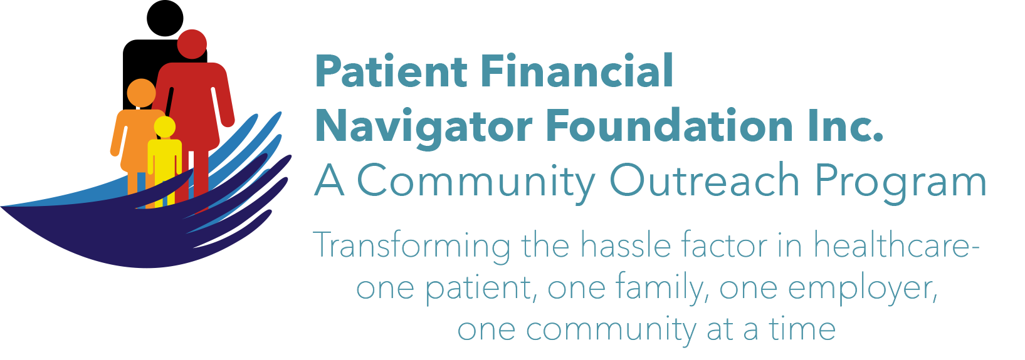 Article for HealthCare Buzz
Times News. May 2018
Article – 16
Turning 65: Safety in the home, Part 1
In this two part series – Safety in the Home – Bryan Wright, PT, DPT, founder of Wright’s Physical Therapy, discusses the “Rule of Too” as it relates to injuries. 24% of injuries are from over-exertion, doing too much too long and too quick to get back to normal. Additionally, there are six high risk factors that factor into injuries. 1) Not enough rest. 2) Out of shape – not physically fit. 3) Lift too much of a load. 4) Doing too repetitive, too often. 5) Awkward body position. 6) For too prolonged period of time.
To reduce risk, Bryan recommends evaluating each risk factor separately. The more ‘yes’ answers to the Rule of Too- the higher the risk. It is a cumulative effect so identify which of the “Rule of Toos” presents the highest risk and address those. Not everyone will have all risk factors for injuries but by identifying which ones are present will minimize home injuries. The Rule of Too can also apply to the work environment. Be aware and reduce risk and injuries. (Part 2 – Dangerous rooms in the home along with simple safety tips.)

Join us! “2nd 2018 Medicare 101, Social Security Benefits and Assistance for Seniors Boot Camp” – Sat, June 9th. 8:30 am – 12:30 pm FREE. CSI Fine Arts. No pre-registration is required. Call Day at 423 9036 for more information. All articles & training material are available on the Foundation’s webpage: PFNFInc.com. Day Egusquiza is the President & Founder of the Patient Financial Navigator Foundation, Inc- an Idaho-based, Family Foundation.

